

A Case Study Report
On
Encoder-Based Data Compression in Embedded Systems

In the course
Digital Logic Design
(2501EC95)
In
B. Tech I Year I Sem

Submitted by
P. DURGA NAIK
25B11CS375

Faculty Signature

Case Study Report
Encoder-Based Data Compression in Embedded Systems

1. Introduction
Embedded systems often operate under strict constraints such as limited memory, low power consumption, and reduced data bandwidth. Efficient data representation is therefore essential. This case study explains how encoder-based data compression, specifically using 8×3 encoders and priority encoders, helps reduce data size and improve system efficiency.

2. Problem Statement
An embedded system collects status signals from 8 sensors. Each sensor generates a digital signal. Sending or storing all 8 signals directly requires 8 bits, increasing memory usage and transmission overhead. A compact representation is needed.

3. Proposed Solution
To reduce data size, encoder circuits are used:
- 8×3 Encoder to compress 8 input lines into a 3-bit output.
- Priority Encoder to handle cases where multiple sensor signals are active simultaneously.

4. System Design
4.1 8×3 Encoder Operation
- The encoder has 8 inputs (D0–D7) and 3 outputs (A2, A1, A0).
- Only one input is assumed active at a time.
- The output is the binary equivalent of the active input number.
Example:
- If D5 = 1, output = 101
This compresses 8-bit data into 3 bits.

Truth Table of 8×3 Encoder
D7 D6 D5 D4 D3 D2 D1 D0 A2 A1 A0
0 0 0 0 0 0 0 1 0 0 0
0 0 0 0 0 0 1 0 0 0 1
0 0 0 0 0 1 0 0 0 1 0
0 0 0 0 1 0 0 0 0 1 1
0 0 0 1 0 0 0 0 1 0 0
0 0 1 0 0 0 0 0 1 0 1
0 1 0 0 0 0 0 0 1 1 0
1 0 0 0 0 0 0 0 1 1 1

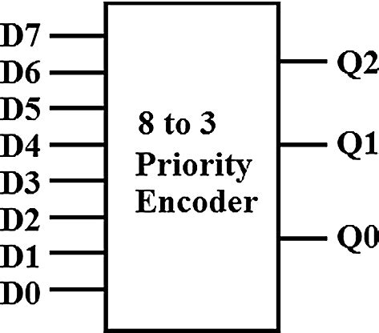

ENCODERS CIRCUIT :
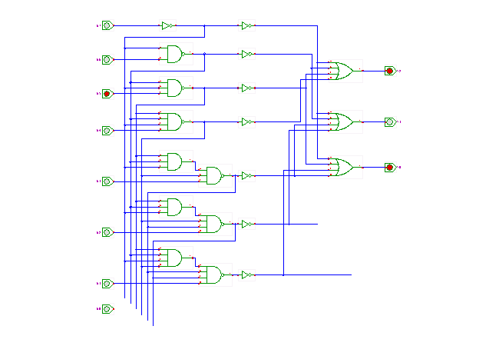

4.2 Priority Encoder Operation
- Used when multiple inputs are active.
- Assigns priority (usually highest-numbered input).
- Outputs the code of the highest-priority active input.
Example:
- If D2 and D6 are both active → output = 110 (D6 has higher priority).

5. Implementation in Embedded System
- Encoder implemented using logic ICs or inside a microcontroller using software logic.
- The compressed 3-bit data is stored or transmitted instead of 8-bit data.
- Priority encoder ensures reliable encoding during simultaneous sensor activation.

6. Results and Benefits
- Data reduction: 8 bits → 3 bits
- Memory savings: Less storage required
- Lower power consumption: Reduced data transmission
- Improved reliability: Priority handling avoids ambiguity
- Faster processing: Less data to handle

7. Applications
- Sensor data compression
- Interrupt handling systems
- Keyboard encoding
- Embedded communication systems
- Control and monitoring devices

8. Conclusion
This case study demonstrates that using 8×3 encoders and priority encoders is an effective method for data compression in embedded systems. The approach significantly reduces data size while ensuring reliable operation, making it ideal for resource-constrained embedded applications.
25B11CS375

